SocialScope

Introduction
Social media platforms like TikTok and Instagram have become essential tools for individuals, brands, and influencers, enabling content sharing, audience engagement, and community building. With over 1 billion users on TikTok and the continued growth of Instagram, particularly among younger audiences, there is rising demand for tools that offer insights into profile performance and engagement trends.
SocialScope was developed in response to this need. It allows users to search for TikTok and Instagram profiles and view key metrics such as follower counts, engagement rates, and recent posts. The platform also integrates PyTrends, a Python library used to analyse the popularity of specific hashtags over time, providing broader context for content strategy.
However, accessing complete analytics through official APIs typically requires business-level access, which was not available for this project. To work around this, the platform uses third-party APIs specifically, the TikTok Scraper API and Instagram Premium API to retrieve essential public data. These APIs, while useful, do not support advanced metrics such as demographics or post-level insights — a limitation frequently discussed in academic research on post-API data access (Ahmed, 2018; Perriam et al., 2019).
As a result, the project pivoted from a full analytics tool to a research-focused platform, offering accessible social media insights through simplified metrics and trend analysis. This report outlines the technical implementation of SocialScope, the challenges faced, and how they were addressed.

2. Implementation

System Architecture
The SocialScope platform is a web-based application built using Flask, a lightweight Python web framework. Flask serves as the backend, handling routing, business logic, and integration with third-party APIs. The platform is designed to provide an intuitive and user-friendly interface, allowing users to search for TikTok profiles, view analytics, and track trending hashtags.
Application Architecture Diagram
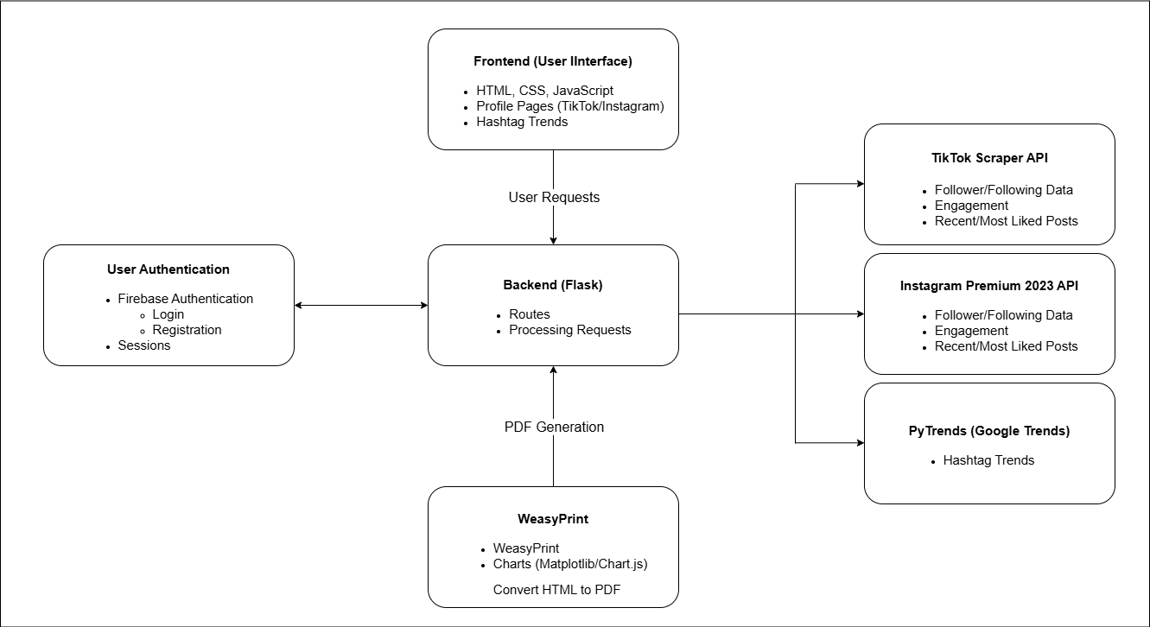
This diagram illustrates the high-level architecture of the system, showing how the frontend, backend, and external services like Firebase and third-party APIs interact.
The platform is split into the following components:
- Frontend: Built with HTML, CSS, and JavaScript, the frontend ensures a fluid, dynamic user experience. Users can easily search profiles, view analytics, and explore trends.
- Backend (Flask): Handles routing, user authentication, data retrieval from third-party APIs, and session management.

Frontend (UI Design)
The frontend of SocialScope is designed with simplicity and interactivity in mind, offering a responsive interface that makes it easy for users to search for profiles, view analytics, and explore trends.

One of the standout features of the frontend is the graph customisation option. Users can customise charts (bar, pie, or line) and colours to display follower and engagement metrics.
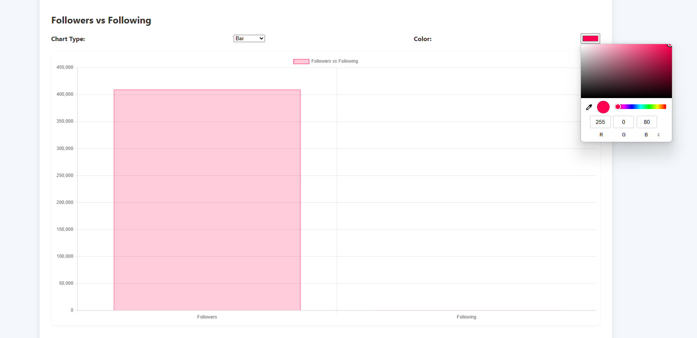
JavaScript is used to fetch real-time data from the backend and dynamically update the profile data and charts without needing a page reload.
A search bar allows users to input TikTok or Instagram usernames to retrieve profile data. Once a username is entered, the platform fetches the relevant information via API calls and displays it in a user-friendly format.
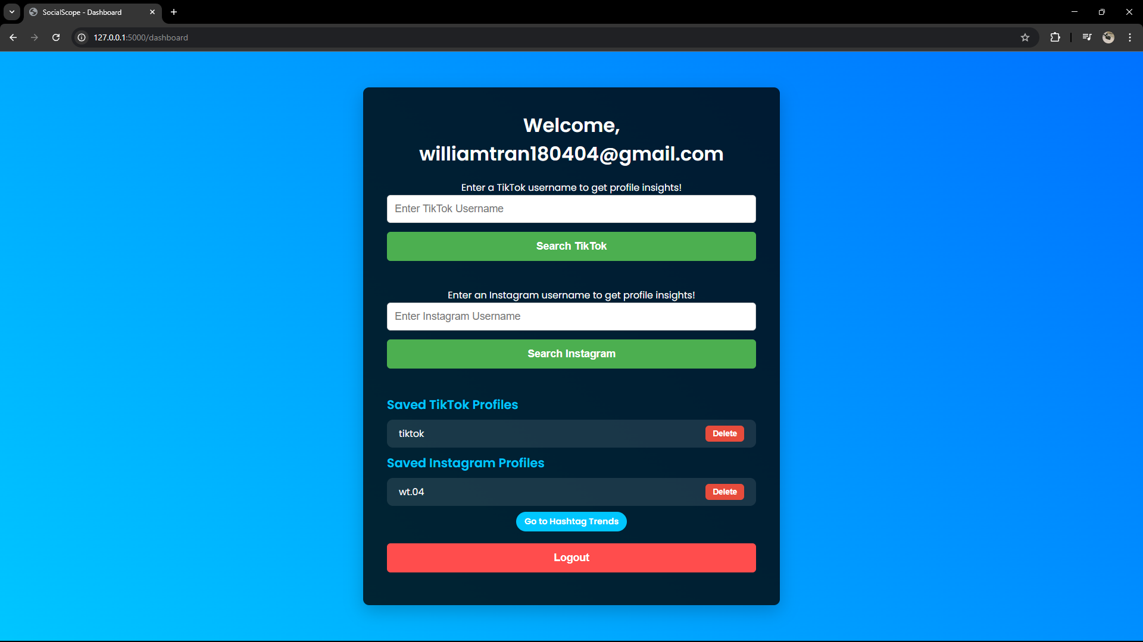
The dashboard provides access to profile searches, trending hashtags, and visual charts. Users can select different data visualisation options, such as bar, pie, or line charts, and customise the chart’s appearance and data metrics.

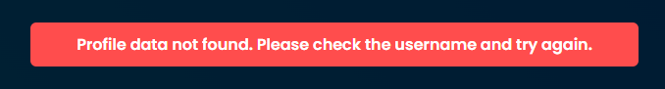
If no data is found for a profile or hashtag, the frontend displays a clear error message to guide the user in correcting their search.
Another key feature of the platform is the Hashtag Trend page, where users can track the popularity of specific hashtags over time. This is done through the PyTrends integration, which allows users to view interest over time for a given hashtag, providing valuable insights into its popularity across social media.
The Hashtag Trend page shows a line graph of hashtag popularity over the past 7 days using PyTrends data. This page provides users with a line graph that displays the interest level for the hashtag, helping them gauge its current trends.
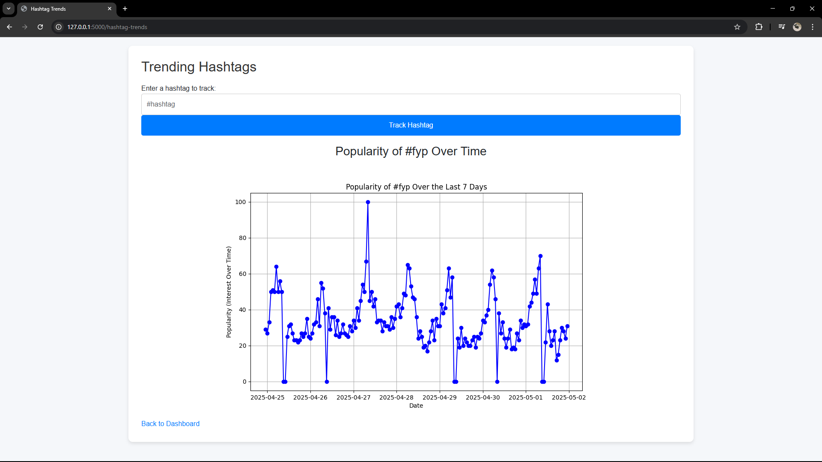
If the hashtag data is available, the trend graph is dynamically rendered on the page. Users can visually assess the hashtag's performance and use it to inform their content strategy or identify emerging trends.
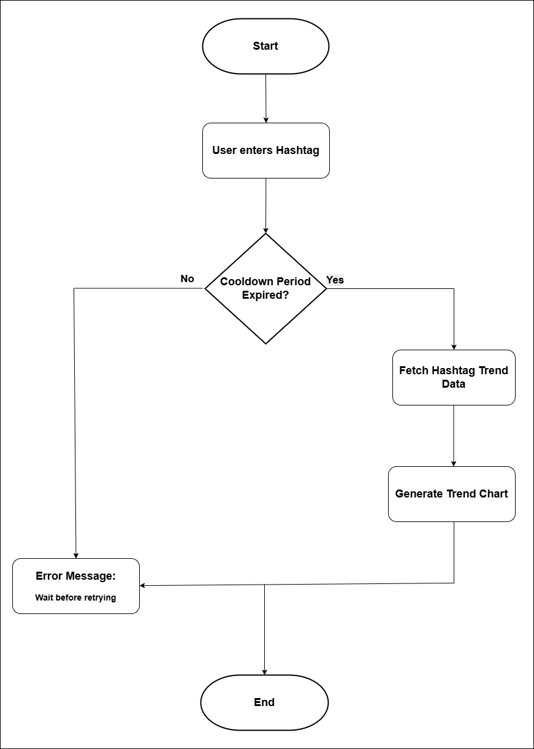
This flowchart depicts the process of fetching and displaying hashtag trends, illustrating how data is retrieved using PyTrends, processed, and displayed on the frontend.

Backend (Flask):
The backend is powered by Flask, which handles routing and API integrations. Flask uses Firebase Authentication for managing user logins and sessions, which later enabled users to securely access saved profiles added as part of the feature expansion.

Key functionality includes:
- User Authentication: Firebase handles user registration, login, and session management, ensuring secure access.
- Profile Data Retrieval: Data from third-party APIs is fetched to display analytics and trends on the frontend.

Session Management and User Authentication:
Firebase Authentication is used to manage user registrations, logins, and session handling. When a user logs in, the system stores their user ID and email in the Flask session, enabling them to stay logged in across requests.

- Sign Up: A user registers with their email and password, and Firebase sends a verification email.
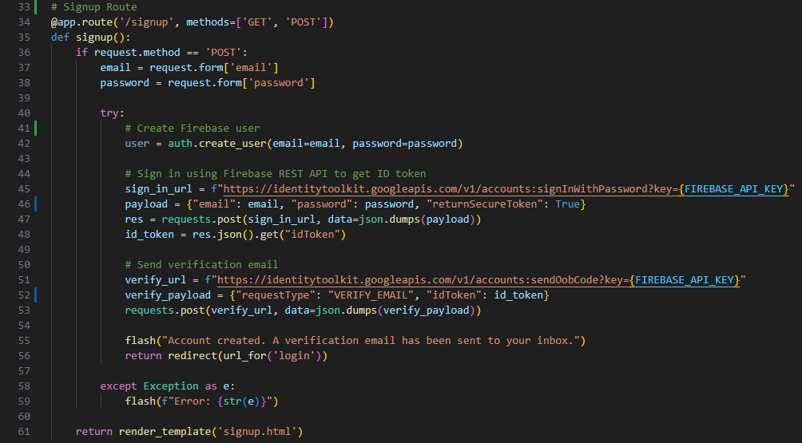

- Login: Users log in with their credentials, and the system verifies the email in Firebase before allowing access to the dashboard.
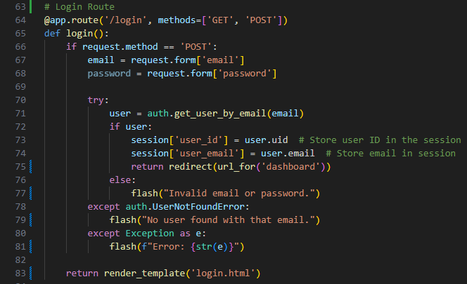
Profile Data Retrieva from APIs:
The backend integrates with third-party APIs to retrieve user profile data. The TikTok Scraper API and Instagram Premium API are used to fetch profile statistics such as follower count, engagement rate, and recent posts. These APIs are called via the backend and the data is processed before being sent to the frontend for display.

API Integration Flow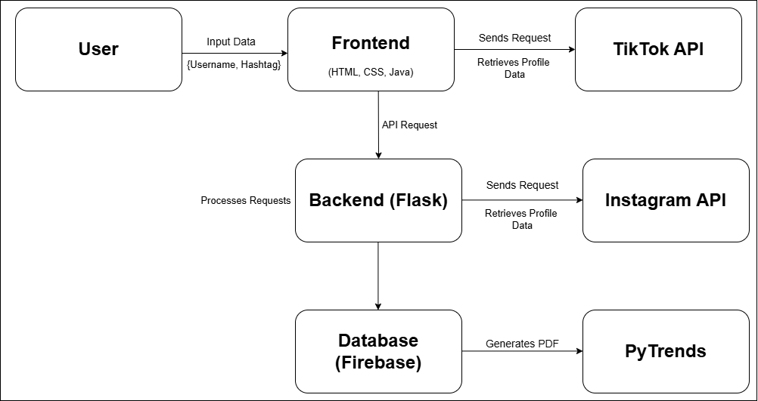
This diagram shows how the backend interacts with external APIs to fetch data, process it, and deliver it to the frontend for display.

- TikTok Profile: Profile data, such as followers count, likes, and recent posts, is fetched using the TikTok Scraper API.
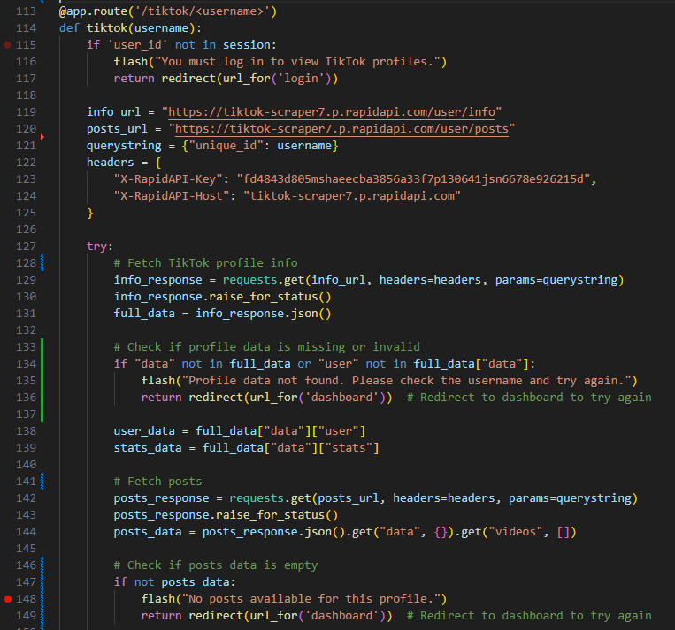

- Instagram Profile: The Instagram Premium API fetches user data, including followers count, profile bio, and recent posts.
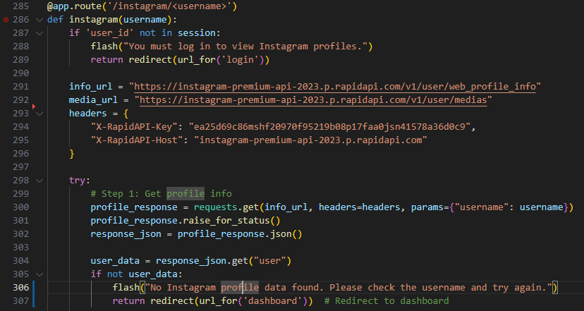

Profile Management
- Save Profile: This added functionality allows users to bookmark profiles to their account for quicker access in later sessions.
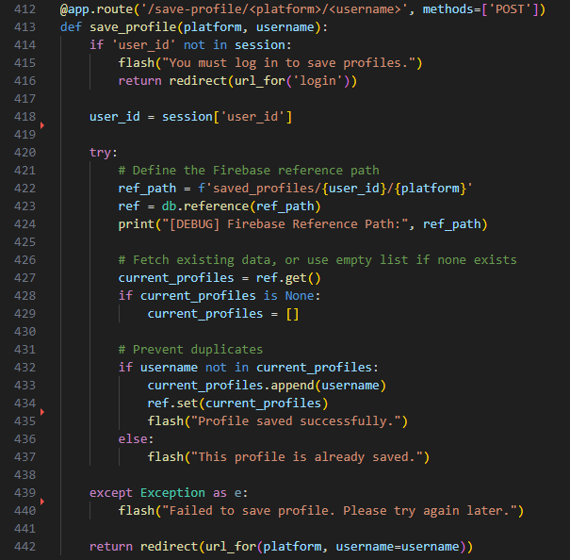
- Delete Profile: Users can remove any previously saved profiles, maintaining control over their stored data.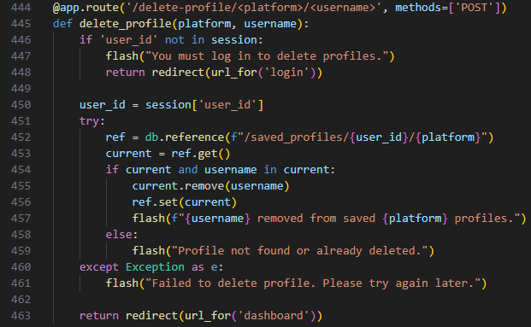

Error Handling and Edge Cases
Error handling is essential to ensure a smooth user experience when interacting with external APIs and user inputs. In SocialScope, several mechanisms are in place to handle issues such as API failures, invalid profiles, and network issues. The platform uses flash messages to notify users when errors occur, and employs retry mechanisms to ensure data is retrieved successfully when possible.
The following flowchart illustrates the main steps involved in error handling:
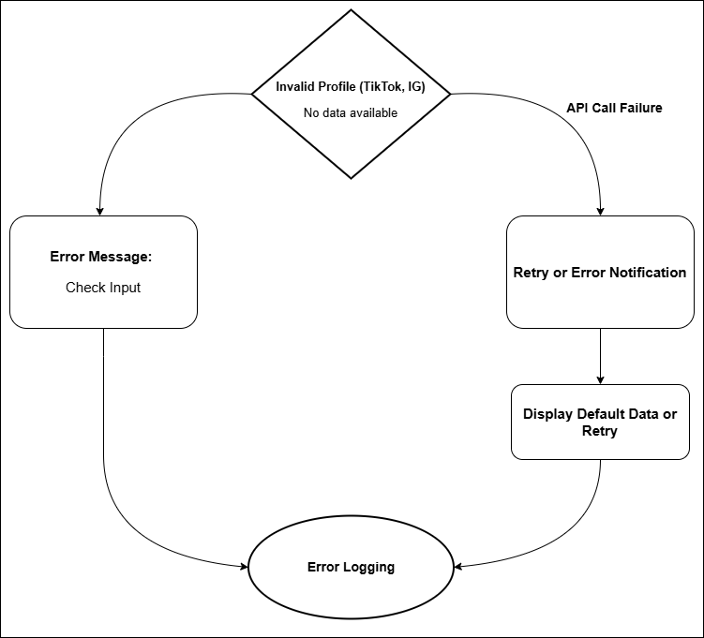

Error Handling Process
- Invalid Profile (TikTok, Instagram):
If the user enters an invalid or non-existent profile (for TikTok or Instagram), the platform checks the API response. If the profile is not found, a flash error message is displayed, prompting the user to check their input.
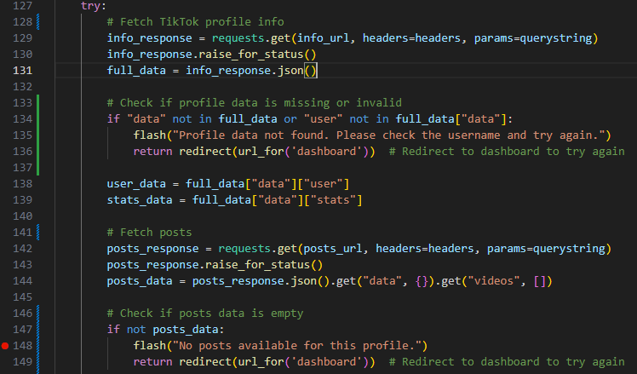

- API Failures
When making requests to third-party APIs such as TikTok Scraper API or Instagram Premium API, network issues, rate-limiting, or unavailability of services may occur. These errors are handled using try-except blocks. If an error is detected, a flash message is displayed to the user, and the system prompts them to try again later.

- User Authentication Failures
In the signup and login routes, errors related to user authentication (e.g., incorrect credentials or missing accounts) are caught, and a flash message informs the user of the issue.
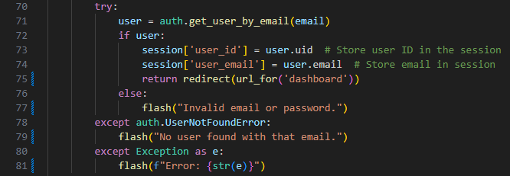

- Saving and Deleting Profiles
As this was an added feature, errors related to saving or deleting profiles are handled gracefully to maintain reliability. The system ensures that users are informed when their actions fail.
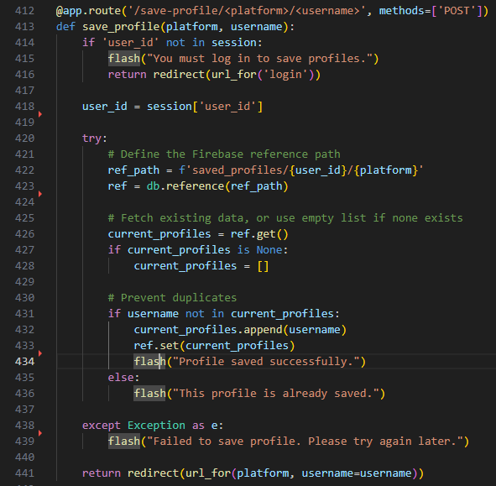
- Hashtag Trends Error Handling:
The hashtag-trends route uses the PyTrends API to fetch trending hashtag data. If there are network issues or rate-limiting occurs, the system informs the user with an error message.
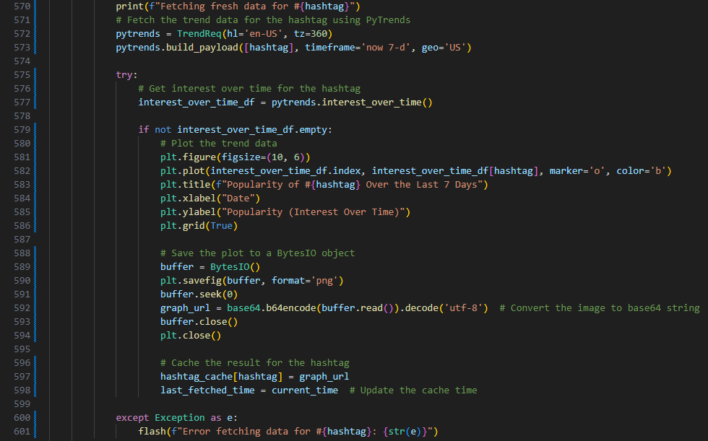

3. Detailed Technical Description

Introduction to Technical Architecture
The original aim was to allow users to connect their Instagram and TikTok accounts via OAuth to access in-depth analytics using official APIs. However, due to business account requirements and restricted API access, the project pivoted towards a research-focused analytics tool. This shift led to the use of third-party APIs and the addition of features such as hashtag trend tracking and sentiment-based exportable reports to ensure functionality and academic depth.
The SocialScope platform is a web-based application that allows users to track and analyse social media profiles, focusing on TikTok and Instagram, while also enabling the monitoring of hashtag trends. The backend of the platform is powered by Flask, a lightweight Python framework, while Firebase is used for user authentication and session management. External APIs are integrated to retrieve profile data from TikTok and Instagram, as well as trend data for specific hashtags via PyTrends.

Backend Architecture
The backend of SocialScope is primarily built using Flask, chosen for its lightweight and flexible nature, which is ideal for a project that requires rapid development and easy integration with external services. Flask handles all server-side logic, including routing, data fetching, user management, and interaction with APIs.

- Flask Routes
Flask routes are designed to manage various user requests, such as logging in, fetching profile data, and rendering trend charts. The routes are mapped to specific functions that interact with backend services and return dynamic responses to the user. Routes handle all major actions within the app, from authentication to rendering the user dashboard.
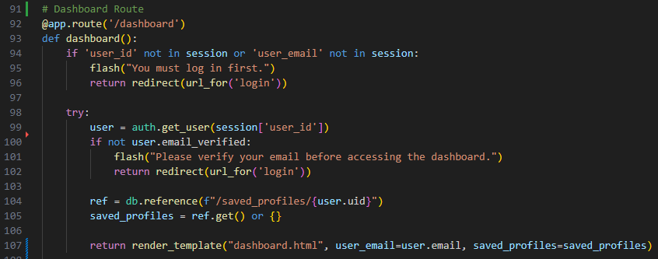
This route checks user login status and fetches any saved profiles from Firebase — a feature added during the system’s evolution.
- API Integration
The backend integrates with three key third-party APIs: TikTok Scraper API, Instagram Premium API, and PyTrends API.
- TikTok Scraper API: This API is used to retrieve public profile data from TikTok, including follower counts, recent posts, likes, and comments. The TikTok Scraper API was selected due to the limitations of TikTok’s official API, which requires a business account and suffers from quota caps and transparency issues, as highlighted in recent studies (Corso et al., 2024).
- Instagram Premium API: This API allows the platform to access Instagram profile data, such as follower counts, media posts, and engagement rates.
- PyTrends API: The PyTrends API is used to track hashtag popularity over time, providing real-time trend analysis. This feature is essential for users to monitor the success of specific hashtags across different periods.

- Firebase Authentication & User Management
The platform uses Firebase Authentication to handle user sign-ups, logins, and session management. When a user signs up, they must provide a valid email address and password. Firebase then automatically sends a verification email to the provided address. The account is only created after the user confirms their email by clicking the verification link. This step ensures that only verified users can access the added functionality of saving and managing profiles. Sessions are securely managed using Flask, with the user’s ID and email stored temporarily in the session for authenticated interactions.

Originally, OAuth 2.0 was intended for secure login through social platforms. Due to access restrictions with TikTok and Instagram’s official APIs, Firebase Authentication was adopted instead. This allowed the application to offer a secure login and session-based experience using email/password authentication, while still enabling profile saving and basic user-specific functionality.

Frontend & User Interaction
The frontend is built using HTML, CSS, and JavaScript, providing a responsive, dynamic user experience. JavaScript is used extensively to interact with the backend and update the user interface in real time, especially when displaying profile data and trend charts.
- User Interface (UI)
The platform’s UI is designed to be simple and user-friendly. It enables users to search for TikTok and Instagram profiles, view detailed analytics (such as likes, comments, and engagement rates), and track hashtag trends. The dashboard page displays user-saved profiles, a late-stage enhancement, alongside trend analysis visualisations.
- Chart Generation
Visual representation of data is crucial to understanding profile performance and trends. The platform uses Matplotlib and Chart.js for rendering charts. These charts include metrics such as likes, comments, views, and engagement rates over time. Users can choose from various chart types (bar, line, or pie charts) to tailor the visualisation to their preferences.
- Hashtag Trend Analysis
The Hashtag Trends page allows users to enter a hashtag and view its popularity over time. Using PyTrends, the platform fetches real-time trend data for the hashtag, which is then presented as a graph. This allows users to analyse the performance of hashtags and monitor their growth.
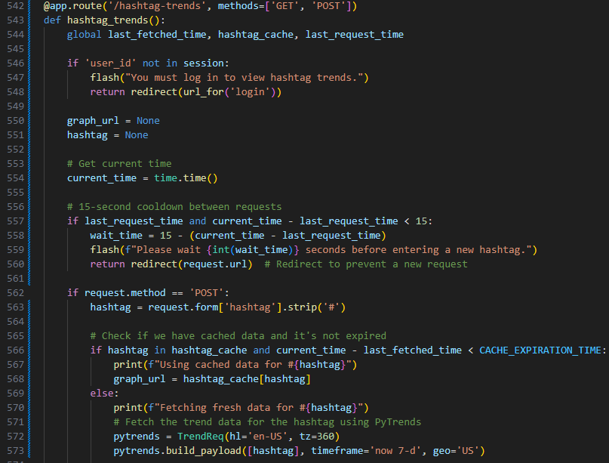
This route processes the input hashtag, queries PyTrends for the trend data, and generates a line chart showing the hashtag's popularity.

Error Handling and Edge Cases
Robust error handling has been built into every part of the application to maintain a smooth and responsive user experience, particularly when dealing with unreliable external APIs or unpredictable user input.
- Invalid Input: If a user enters an incorrect TikTok or Instagram username, or an unsupported hashtag, the system checks the API response. Should the profile or data not exist, a friendly error message is flashed on screen, encouraging the user to try again with a valid input.

- Third-Party API Failures: As the platform relies on external APIs (such as TikTok Scraper or Instagram Premium), occasional issues like network failures or rate-limiting can occur. These are handled gracefully using try-except blocks in the backend. Rather than crashing or freezing, the app informs the user that the data couldn't be retrieved and advises them to retry shortly.

- Firebase Errors: Since profile saving was added as a feature enhancement, related issues are caught, and users are notified accordingly. If this happens, the user is notified that their action couldn’t be completed, and no data is lost in the process.

- Rate Limiting (PyTrends): Due to restrictions placed on how often trend data can be requested, the PyTrends integration occasionally hits usage limits. In such cases, the user is politely advised to wait before attempting another search.
These mechanisms ensure that the platform remains reliable and clear, even when underlying services are not.

PDF Report Generation
One of the key usability features of SocialScope is the ability to generate downloadable PDF reports. This is especially helpful for content creators who want a snapshot of their performance that they can save, print, or share.
- Chart Conversion: Charts generated using Chart.js on the frontend are converted into images using the HTML Canvas API. These are then encoded in base64 format and embedded into an HTML template.

- HTML to PDF: This custom HTML is passed to WeasyPrint, which converts it into a clean, high-resolution PDF file. The generated report includes the user’s profile details, relevant charts, and metrics such as follower count, engagement rate, and sentiment breakdown.
This feature allows users to export meaningful insights quickly and in a professional format, helping bridge the gap between casual analysis and business reporting.
To compensate for the limited depth of available API data, additional features were developed to enhance the research utility of the platform. These include:
- A Hashtag Trends page powered by PyTrends for keyword tracking
- Customisable graphs for visual exploration of engagement
- Exportable PDF reports, enabling users to archive or present insights in a polished format
These features support the project's revised research-oriented goal and provide meaningful insight despite external data limitations.

Directory Structure and Deployment
The project has been structured with clarity and scalability in mind, using a modular layout as follows:
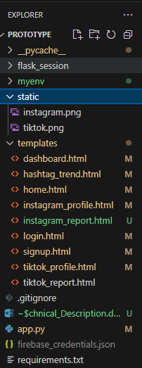
The figure above shows the actual file structure of the application within the development environment (VS Code). This aligns with the modular layout described above and includes templates, backend logic, configuration files, and virtual environment folders.

Security and Ethics
Security and user trust have been prioritised throughout development:
- Authentication: Profile-saving, introduced during a later phase of development, is restricted to authenticated users only. Firebase Authentication ensures that only verified users can access certain features.
- Data Privacy: No sensitive user data is stored or shared. Only public profile data from TikTok and Instagram are accessed. Users have the option to save profiles — a feature introduced to enrich interaction and increase platform complexity due to limited API access. Saved profiles are linked to a user’s account and can be deleted at any time.
- Ethical Use of APIs: The third-party APIs used comply with public data guidelines. Rate limits and fair use policies have been respected. The project does not scrape or bypass platform restrictions.
- GDPR Considerations: As per GDPR guidance, no personally identifiable data is processed without user consent. Users are informed when data is stored, and full control is given to delete any saved information.

Evaluation and Testing
Testing for SocialScope focused on verifying functionality, ensuring user-friendliness, and collecting feedback from real users. Both manual testing and user evaluation methods were used to assess how effectively the platform met its revised goals.

Functional Testing
Manual testing covered all major features, including:
- Searching for TikTok and Instagram profiles
- Handling invalid usernames, API responses, and user authentication (login/signup)
- Chart customisation (bar, line, pie)
- Saving and deleting user profiles
- Hashtag trend analysis via PyTrends
- Generating downloadable PDF reports
Each function was tested with valid and invalid inputs to ensure appropriate feedback messages and interface stability. Screenshots documenting each tested feature, including valid/invalid inputs, profile saving, PDF generation, login/signup, and chart customisation, are provided in Appendix A – Manual Testing Evidence, each accompanied by figure captions for clarity.

Usability and User Feedback
To evaluate user experience, a survey was distributed to 5 influencers and 8 general users. Respondents watched a demo of the platform and provided feedback through a google form. Questions covered ease of use, favourite features, suggestions, and satisfaction with visualisations.
Most users rated the platform as intuitive and useful. Influencers especially appreciated the profile-saving function and PDF export, while casual users highlighted the chart customisation as a helpful learning tool. Minor suggestions included adding mobile responsiveness and deeper analytics in future updates.

A full summary of survey results, including visual charts, demographic breakdown, and direct quotes from influencers, is presented in Appendix B – User Survey Feedback. Verification screenshots confirming influencer identities are included in Section B4 of the appendix.

Limitations
Some third-party APIs, particularly PyTrends, experienced temporary rate-limiting during testing. Incomplete API access also limited the depth of analytics compared to official OAuth-based tools. Nonetheless, added features such as saving profiles and PDF exports ensured the platform remained technically and academically robust despite the known research limitations of restricted APIs (Perriam et al., 2019).

Appendix A – Manual Testing Evidence
This appendix contains screenshots and brief descriptions of manual testing performed on the SocialScope platform. Each figure demonstrates a specific feature or testing scenario.

Figure A1: Successful TikTok/Instagram Profile Search
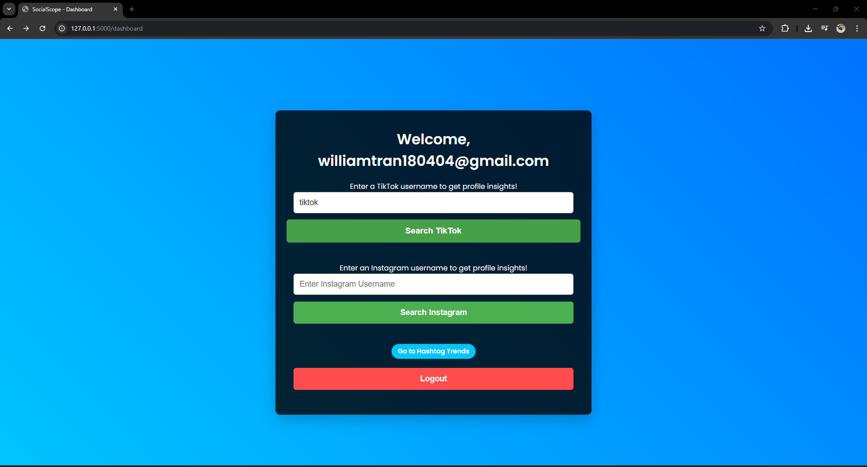
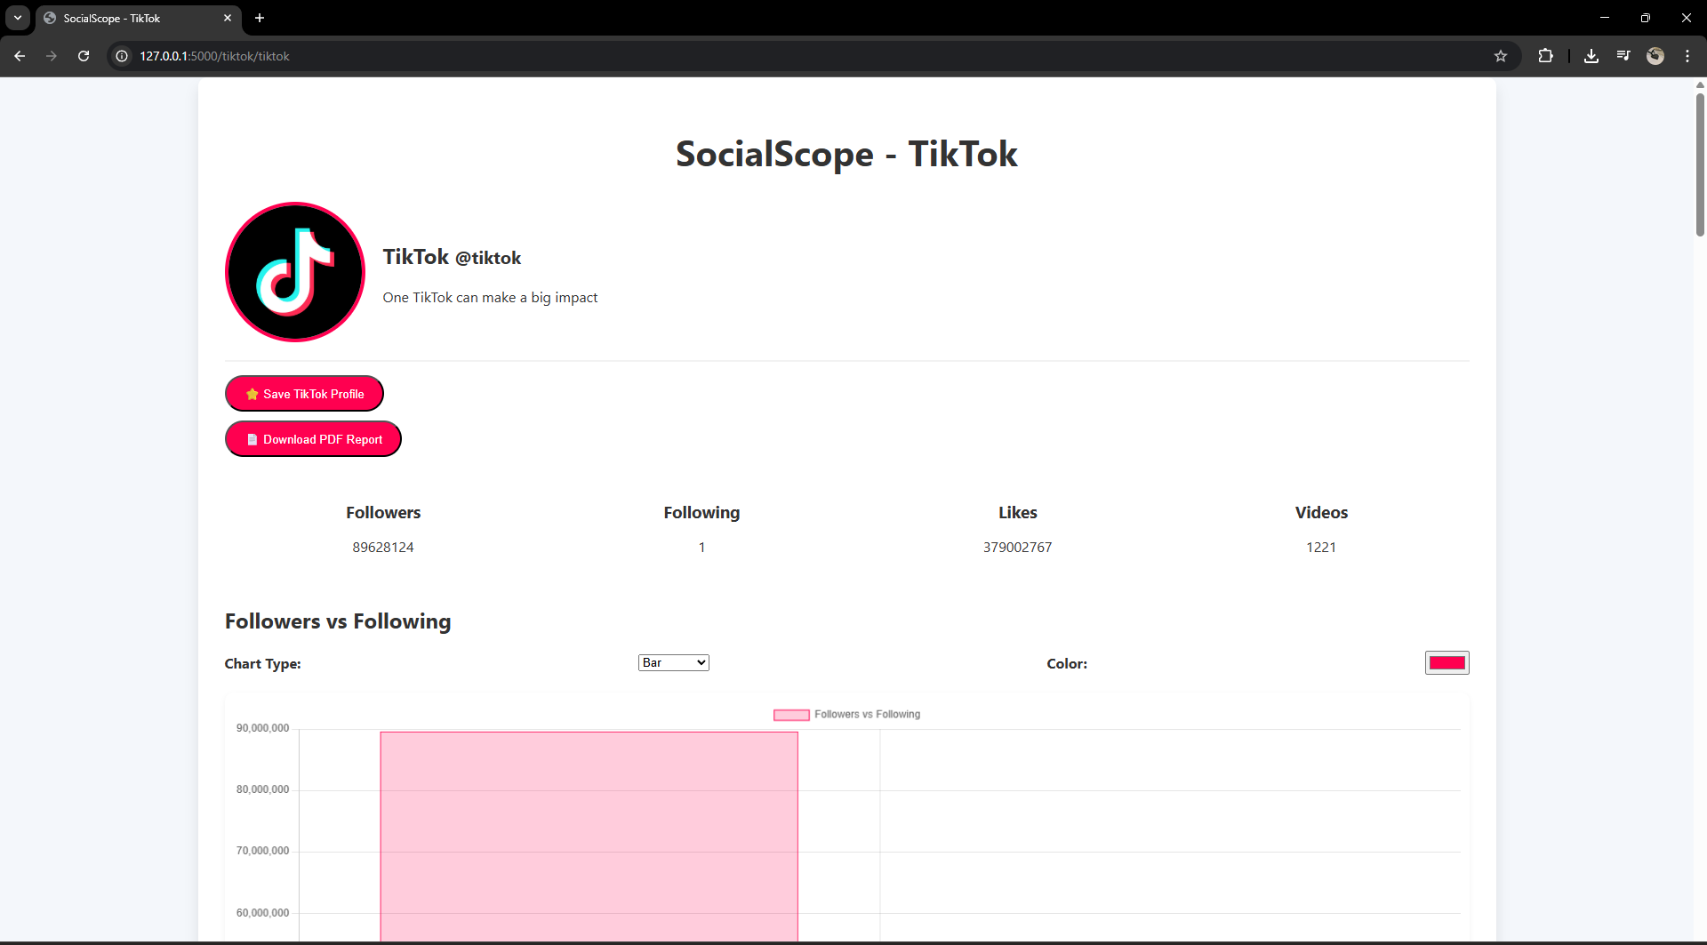
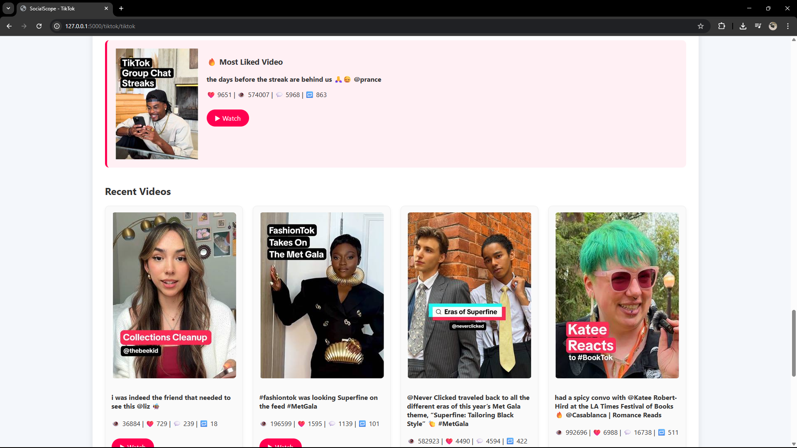

Figure A2: Invalid TikTok username (error handling test)
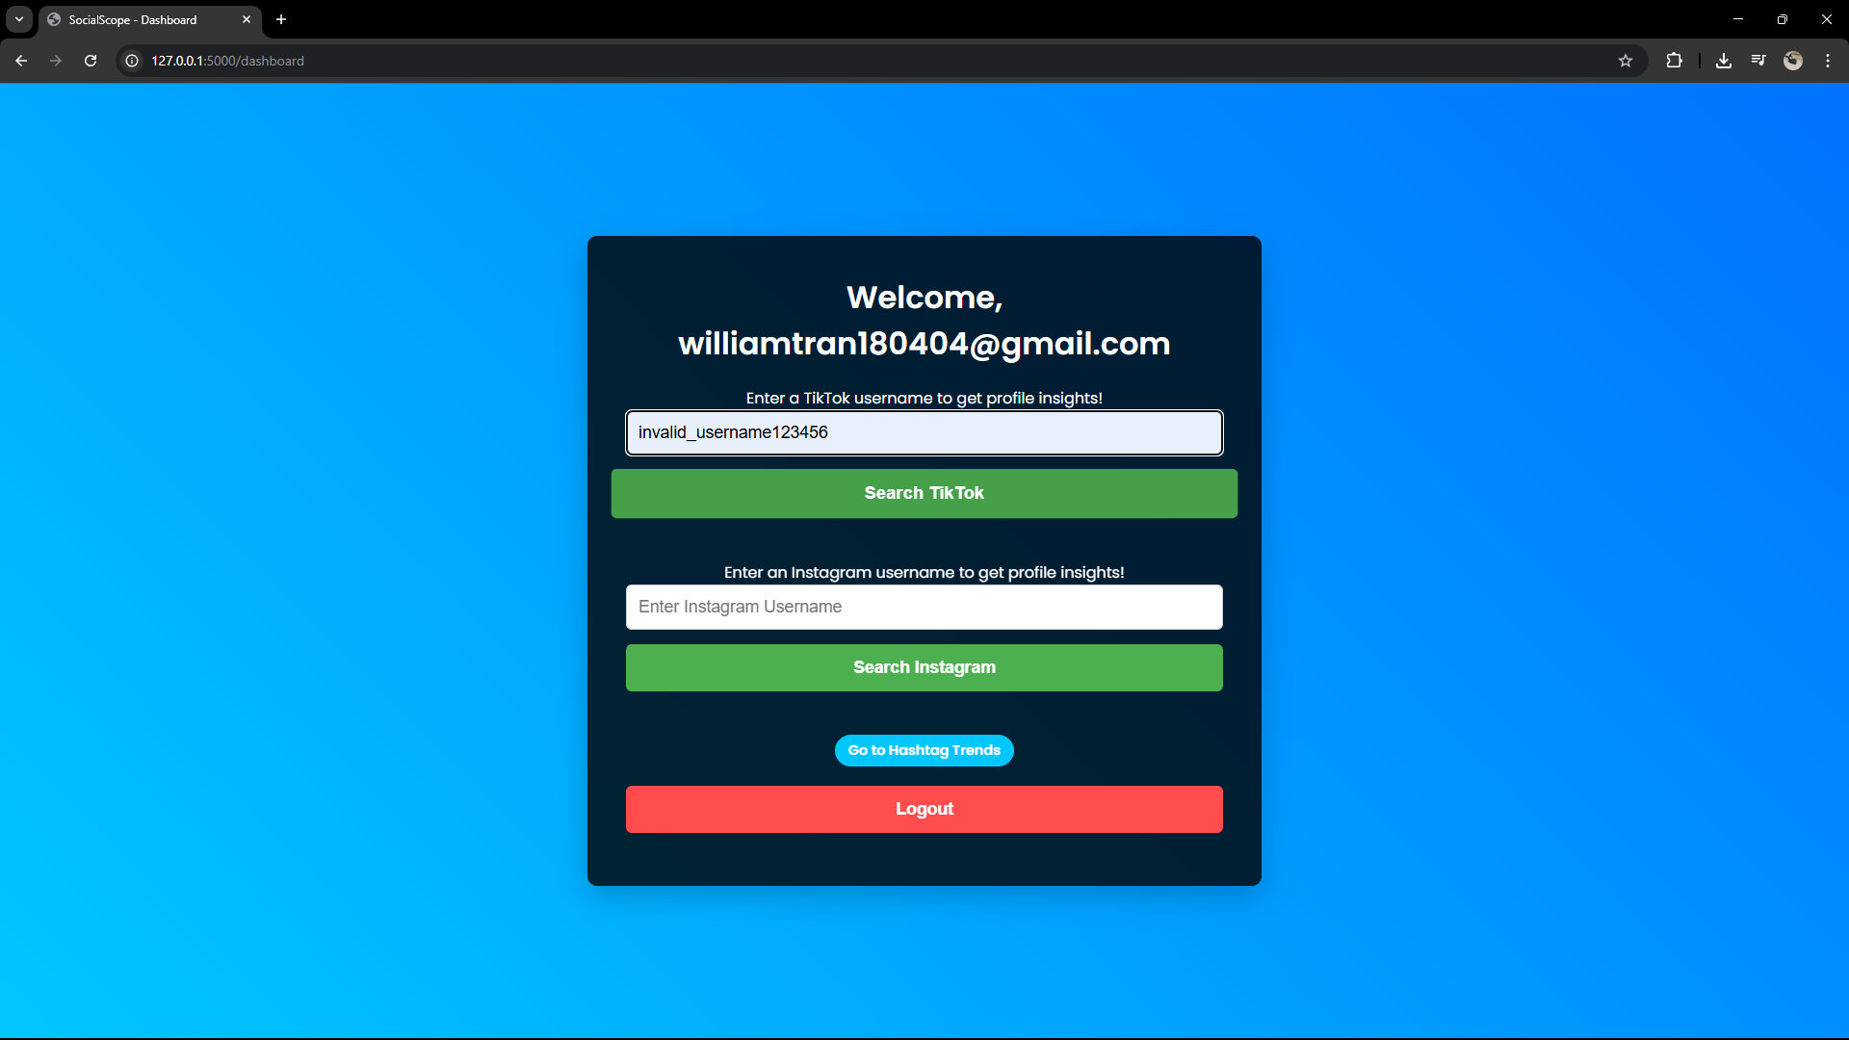
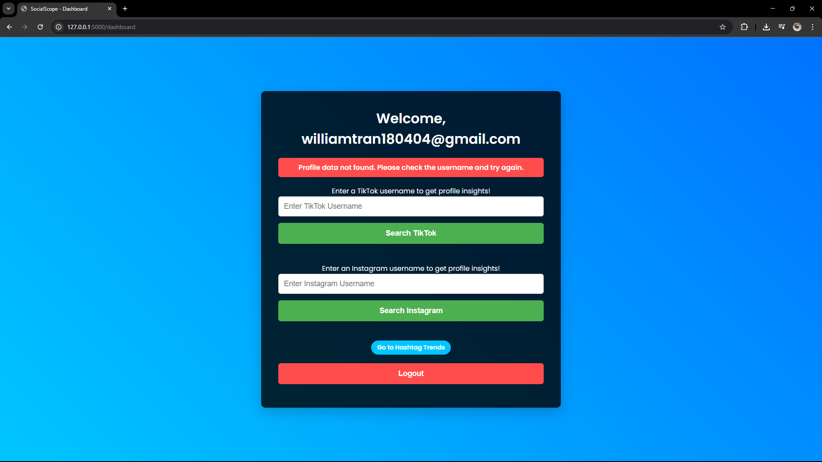

Figure A3: Saving a TikTok profile to user account
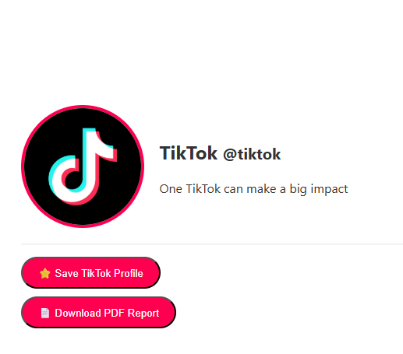
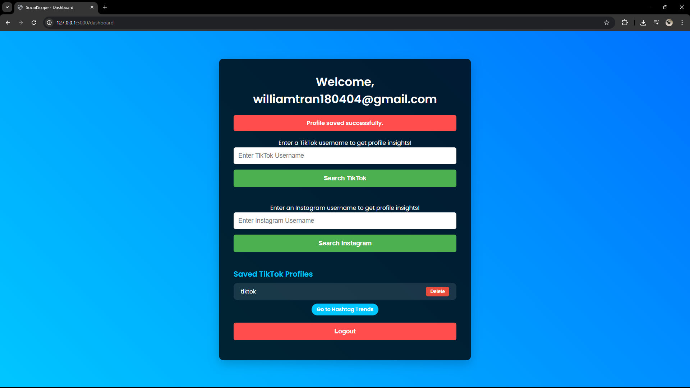

Figure A4: Deleting a saved TikTok profile
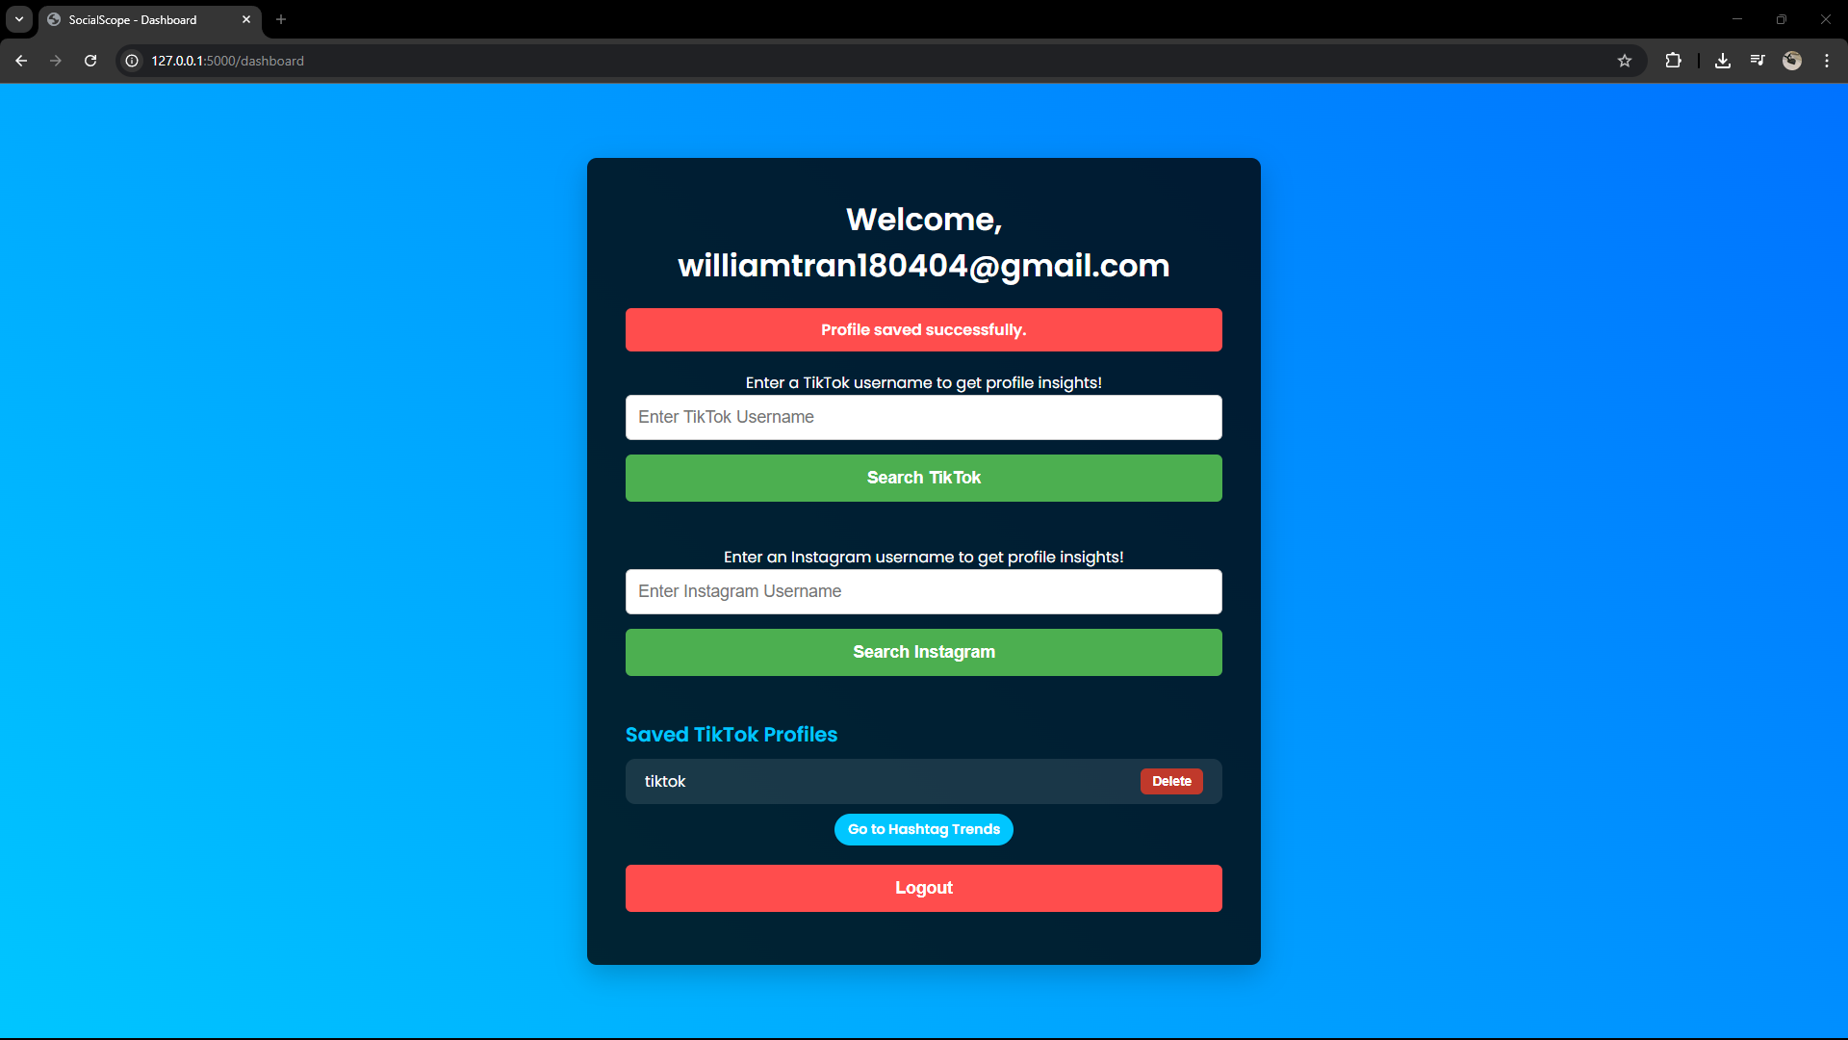
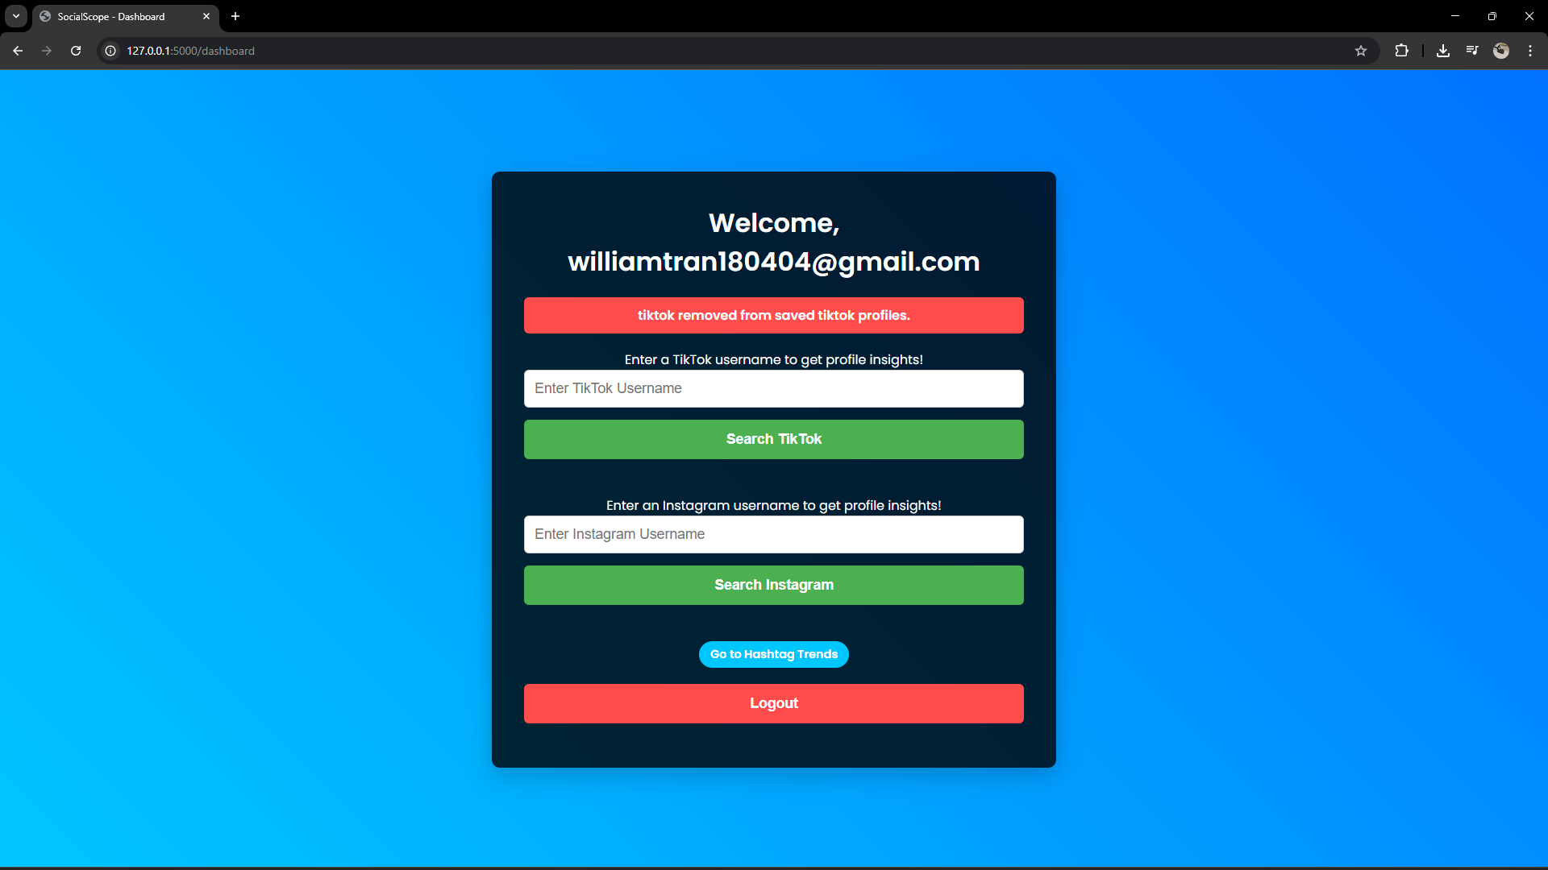

Figure A5: Customising chart view (bar to pie chart)
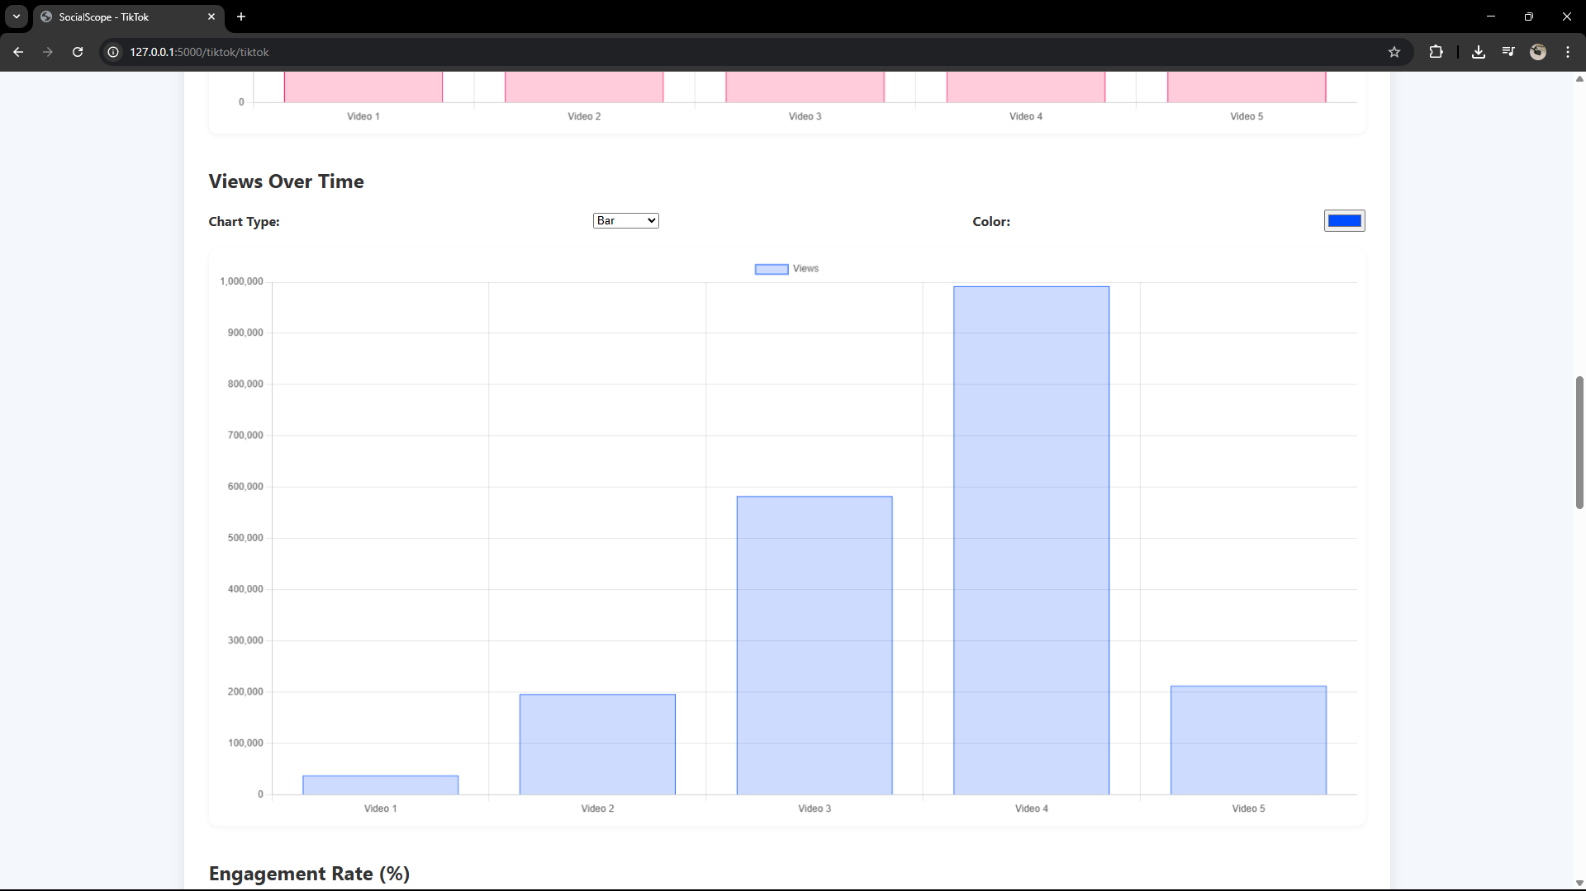
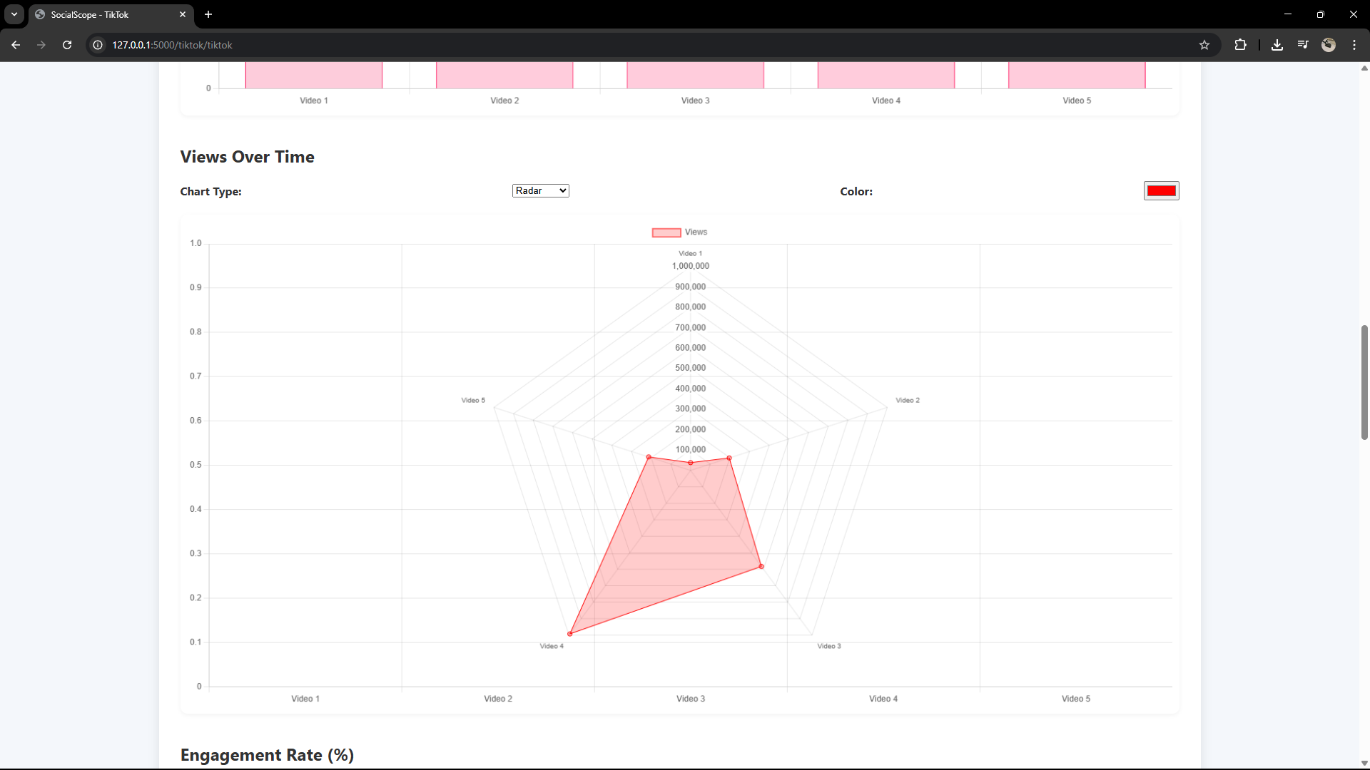

Figure A6: Hashtag trend graph displayed via PyTrends
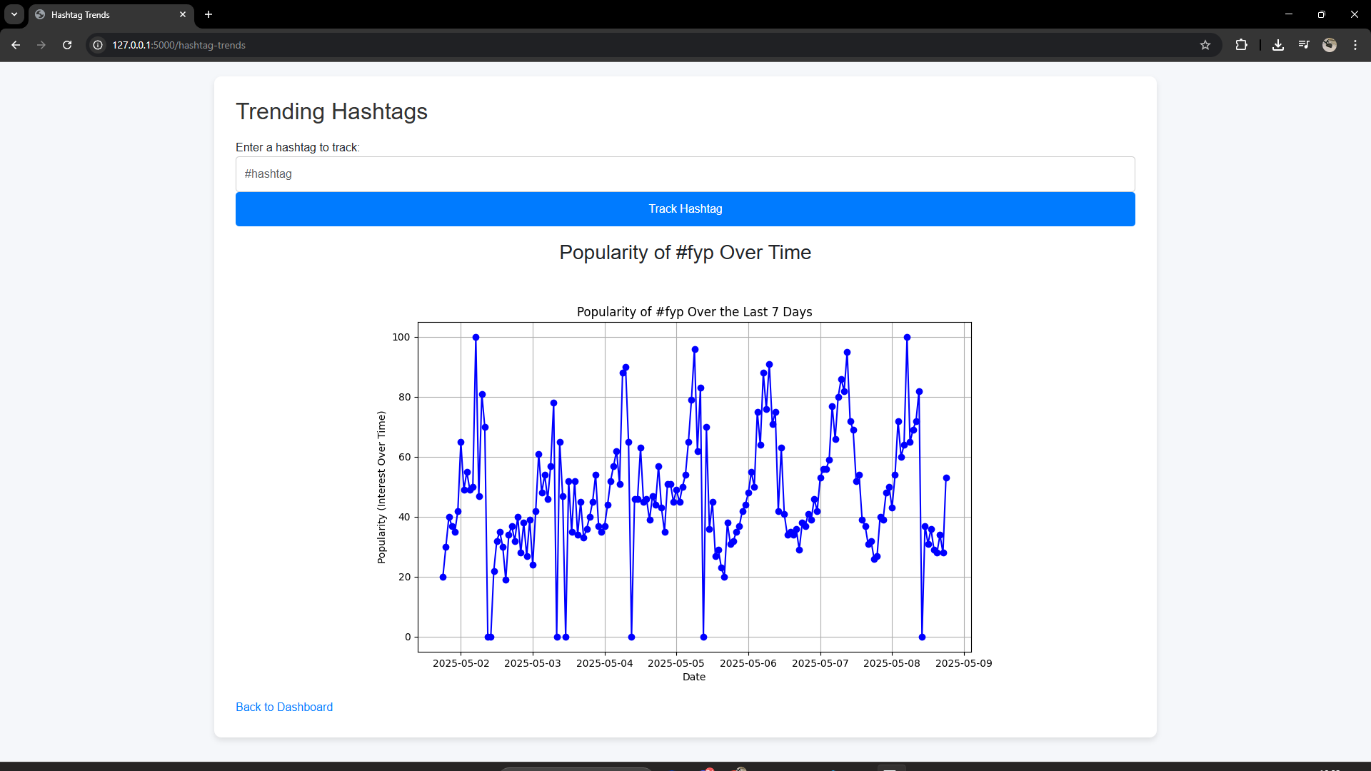

Figure A7: Firebase Login and Signup Page
Signup Form UI
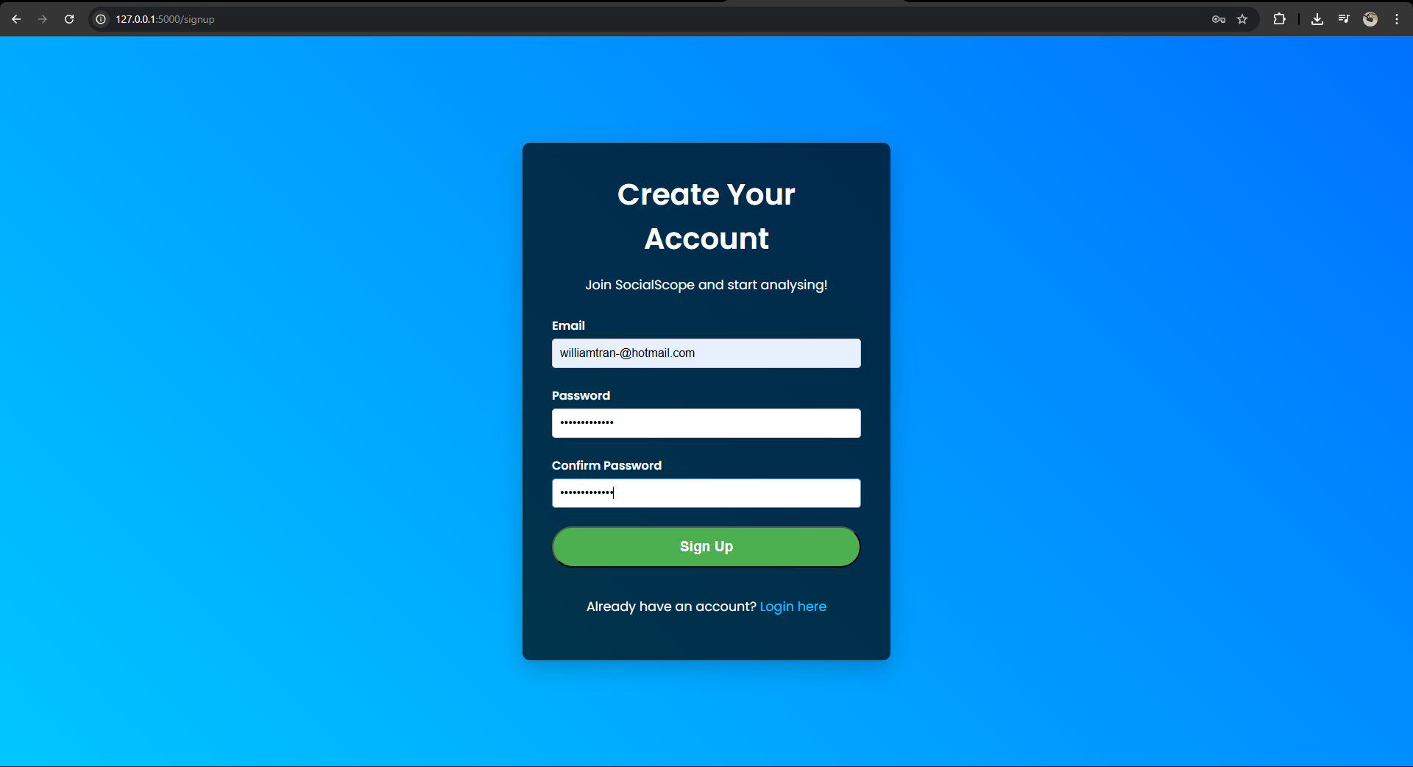

Account creation confirmation (“A verification email has been sent”)
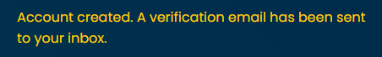
Verification email received
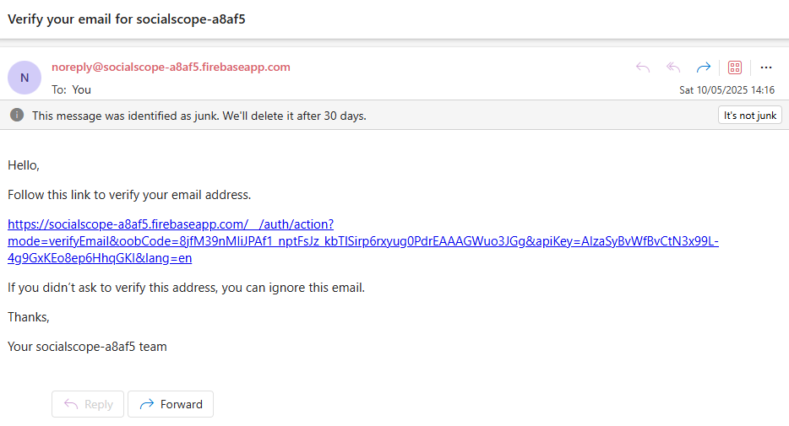
Firebase console showing account created
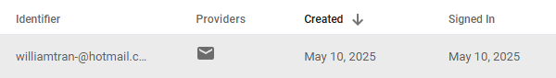
Successful login screen
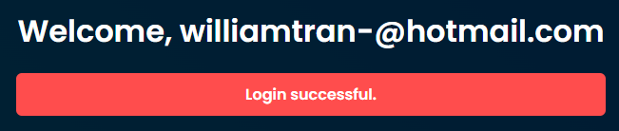

Figure A8: Downloaded PDF report preview
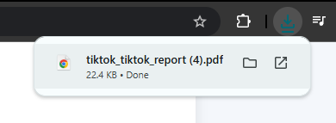
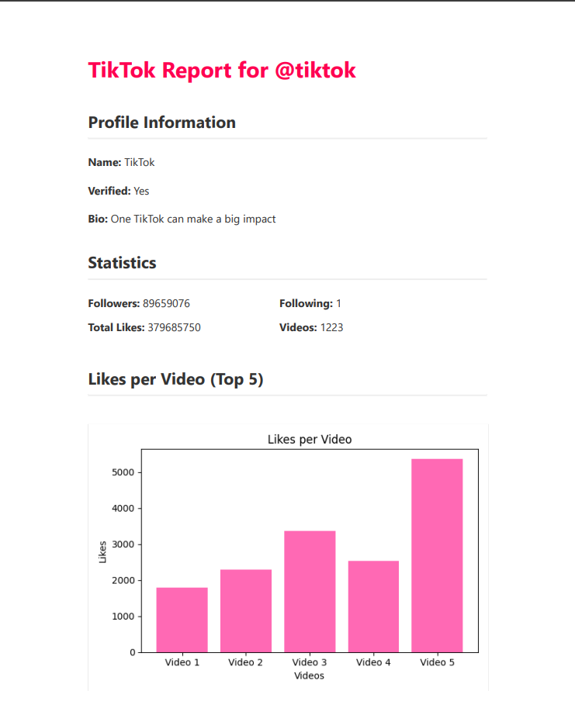

Figure A9: Firebase Realtime Database – Saved Profiles
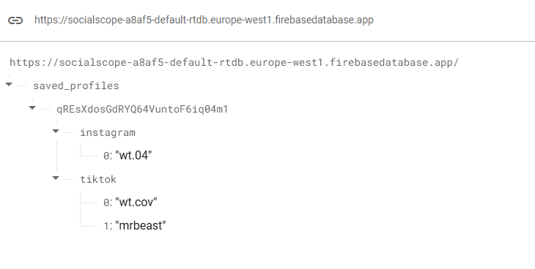
This shows saved TikTok/Instagram profile data stored under unique user IDs in Firebase, verifying that the save/delete functionality writes to the backend database.

Appendix B – User Survey Feedback
This appendix summarises the responses collected from 20 users, including influencers/content creators and general users, who watched the demo video of SocialScope. Feedback was collected through a Google Form and covers platform usability, perceived value, and suggestions.

B1: Participant Demographics
Table: User Type Breakdown
User Type | Number of Participants
Influencers | 9
General Users | 11
Total | 20
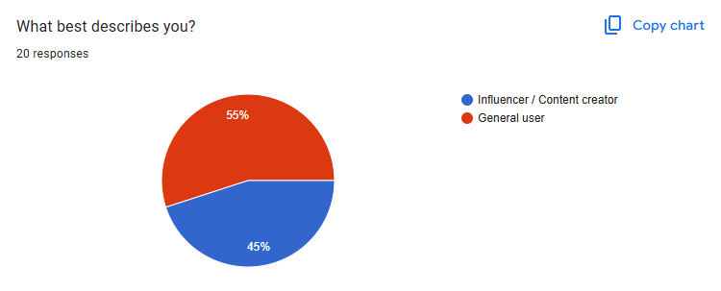

B2: Summary of Results
This section summarises user feedback based on 20 survey responses collected after viewing the SocialScope demo video. Visual representations of each question are included below to illustrate key trends in the data.

Age Group Distribution
Figure B2.1: Respondent age group distribution
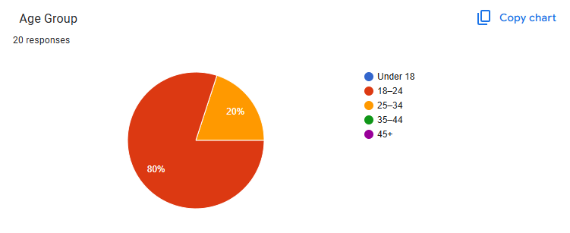

Ease of Use Rating
Figure B2.2: Ratings of platform ease of use (1 = Very difficult, 5 = Very easy)
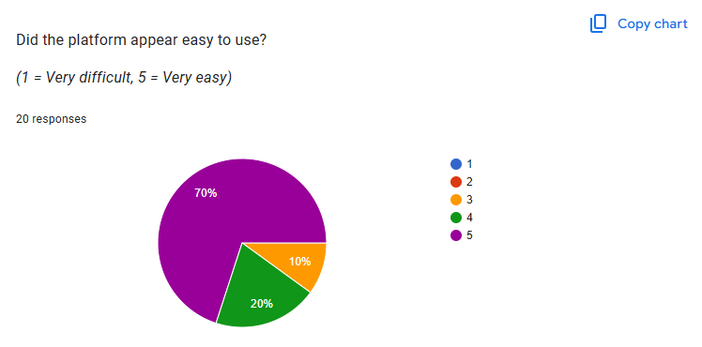

Most Useful Features
Figure B2.3: Features selected as most useful (multiple responses allowed)
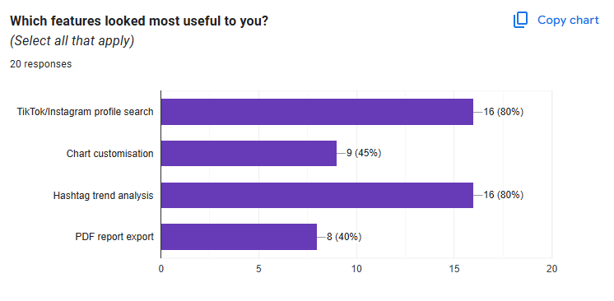

Chart Customisation Clarity
Figure B2.4: Responses to “Was the chart customisation feature clear in the video?”
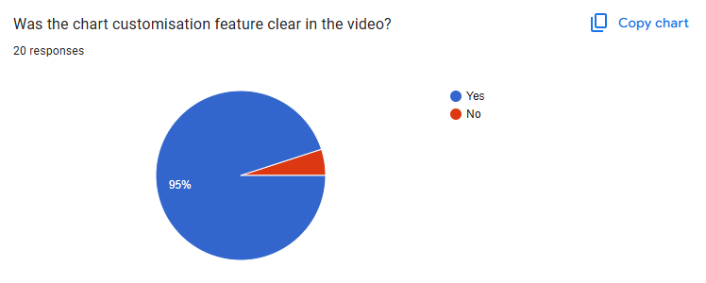

Overall Platform Usefulness
Figure B2.5: Responses to “How useful do you think this platform could be for social media users?”
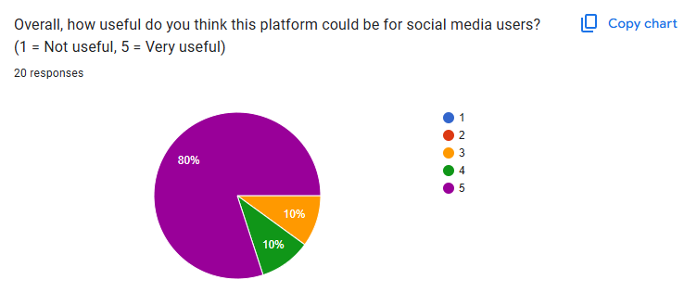

B3: Selected User Suggestions
Below are selected quotes from influencers who completed the feedback form and watched the demo. These responses highlight clarity, feature usefulness, and opportunities for improving SocialScope. Feedback was gathered from participants with a large following and content creation experience.
“The platform was visually clean and easy to follow, especially for users who aren’t tech-savvy. I liked how all the insights were shown clearly, and the ability to customise the charts really helped make the data more digestible. As a content creator, I can see myself using this to quickly review how my account is doing without going deep into complex stats. One suggestion I have is to maybe let users compare two profiles side-by-side or add mini tips based on the data.”
— @dancingintheshed (Influencer)
“I really enjoyed seeing your fleshed out project and I can honestly see it as a real platform used by both big and small creators. It’s incredibly straightforward to navigate and can give direction for people who want to grow into something bigger. The best feature has to be the charts where you can track all things like engagement and views, with the option of changing the chart type being the cherry on top. If I were to add anything, it would be a feature that suggests trending hashtags or highlight best times to post. Just general guidance for creators unsure what trends to follow.”
— @chipotlexpress (Influencer)
“This platform is a comprehensive and efficient way to help creators and businesses excel in their online engagement. However, the interface looks slightly unappealing so maybe the colours and font could be different — but still a platform I would use regardless! Nice!”
— @e.cheongyy (Influencer)
“The structure of SocialScope was very clear and easy to follow from the guide that was given. It seems very accessible when wanting to know your analytics of your page. TikTok and Instagram often take a while before analytics show up, so the way SocialScope delivers insights quickly and effectively is amazing. Would definitely use it if it was accessible by all someday.”
— @notf3lix (Influencer)

B4: Influencer Verification
To ensure the authenticity of the feedback presented in Section B3, this section provides evidence that the responses were obtained from genuine influencers. Each participant was contacted individually on Instagram with a standardised message introducing the project, a link to a short demo video, and a Google Form for submitting feedback.
All influencers shown in this section completed the form and provided valuable insight based on their experiences. Screenshots of their public Instagram profiles, message confirmations, and submitted form entries have been included to verify identity and engagement with the project.

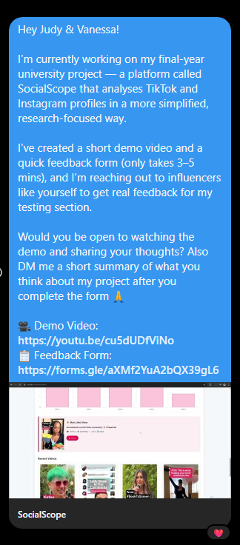
Figure B4.0 – Outreach message to Influencers

@dancingintheshed (Instagram/TikTok)
A well-known K-pop dance duo with over 76,000 Instagram followers. Known for their high engagement and consistent content output.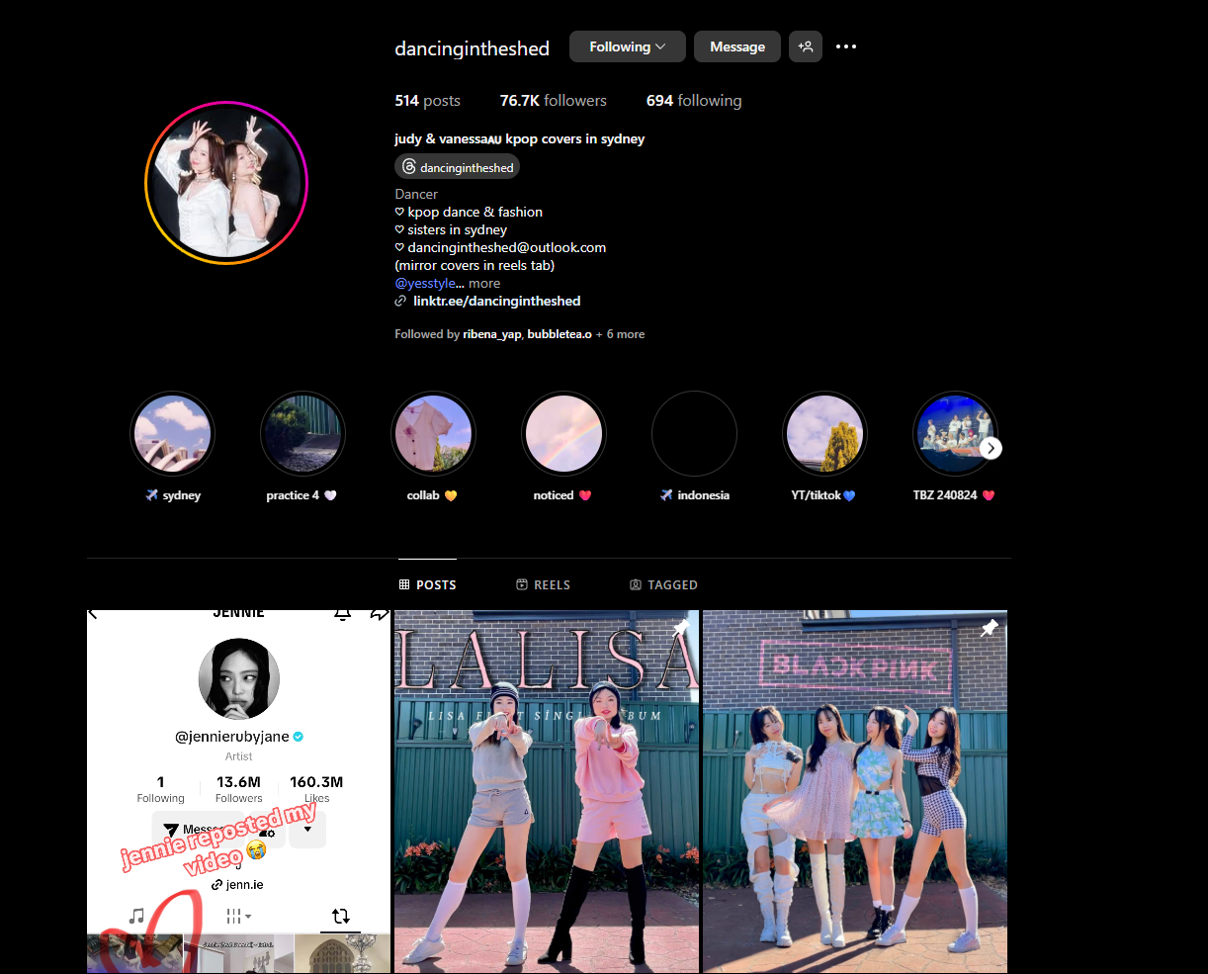
Figure B4.1 - Instagram profile of @dancingintheshed
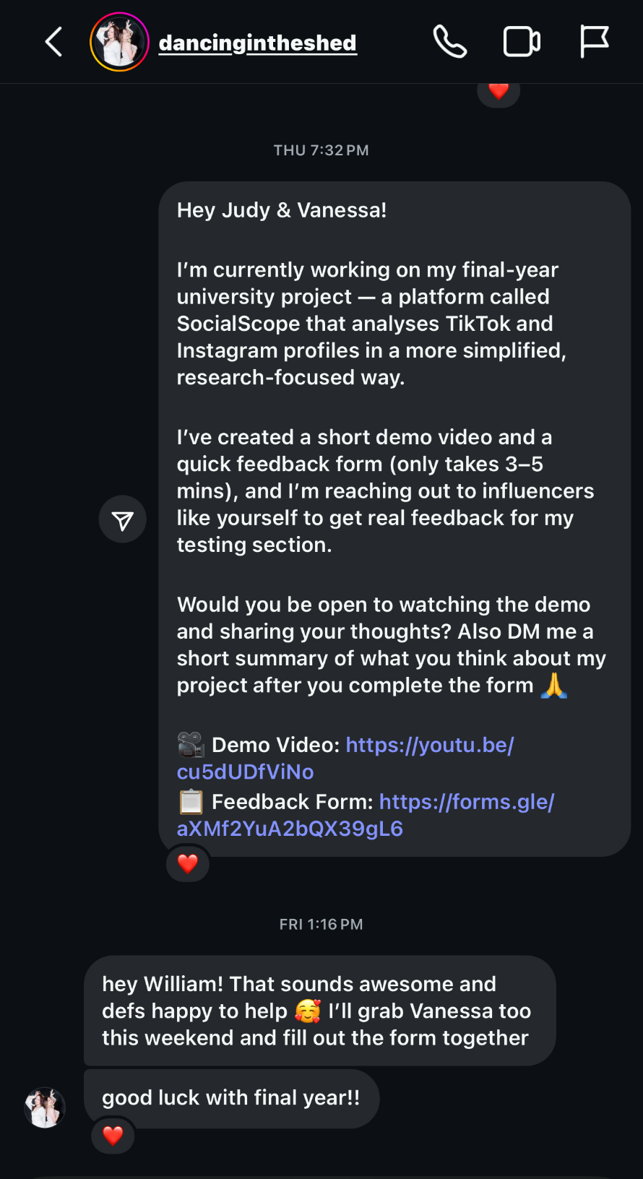
Figure B4.2 - DM confirmation from @dancingintheshed

@chipotlexpress (Instagram)
An active UK-based dancer and content creator with over 1,500 followers. Frequently participates in London K-pop events and showcases.
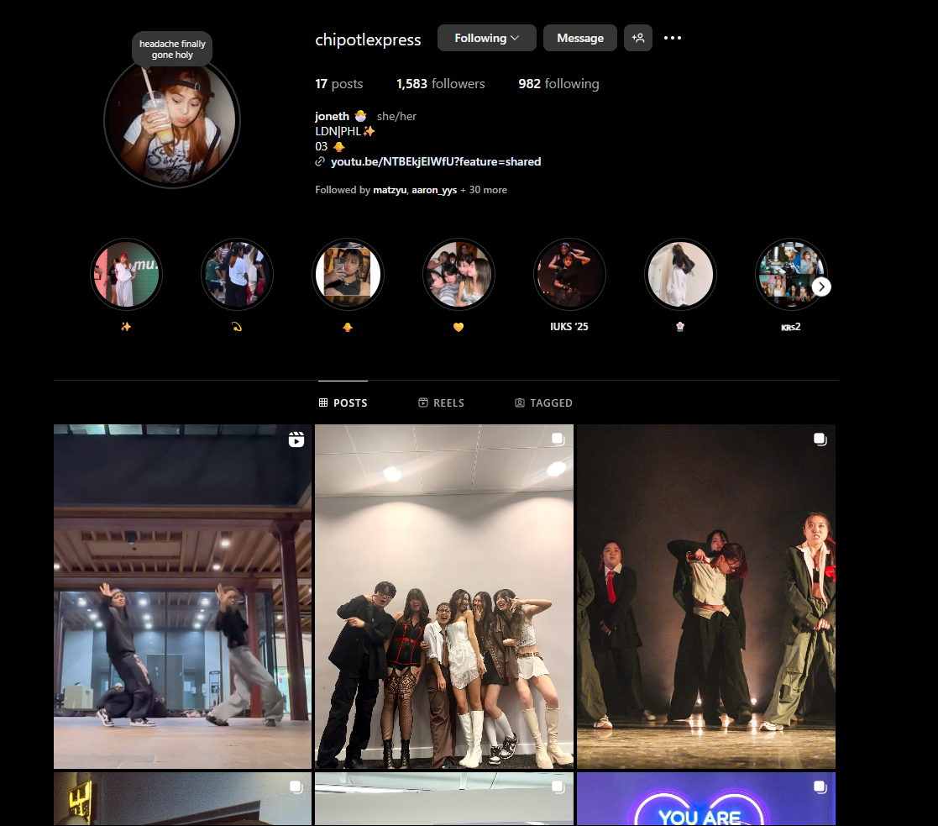
Figure B4.3 - Instagram profile of @chipotlexpress
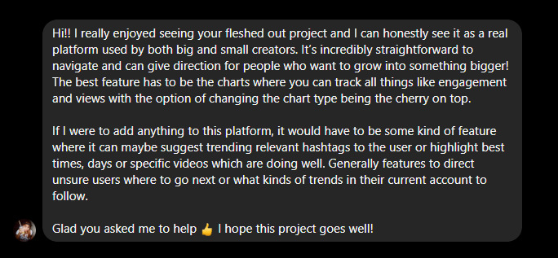
Figure B4.4 - DM confirmation from @chipotlexpress
@e.cheongyy (Instagram)
A professional London-based dancer and Instagram content creator with over 2,000 followers.
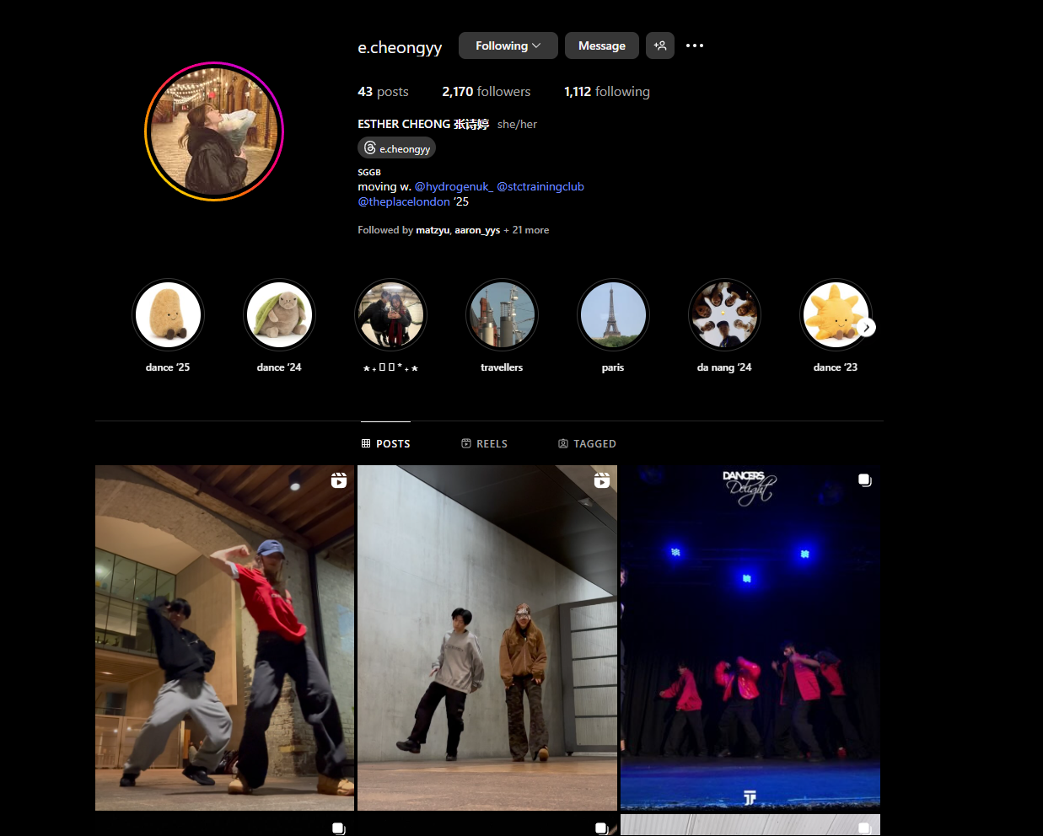
Figure B4.5 - Instagram profile of @e.cheongyy
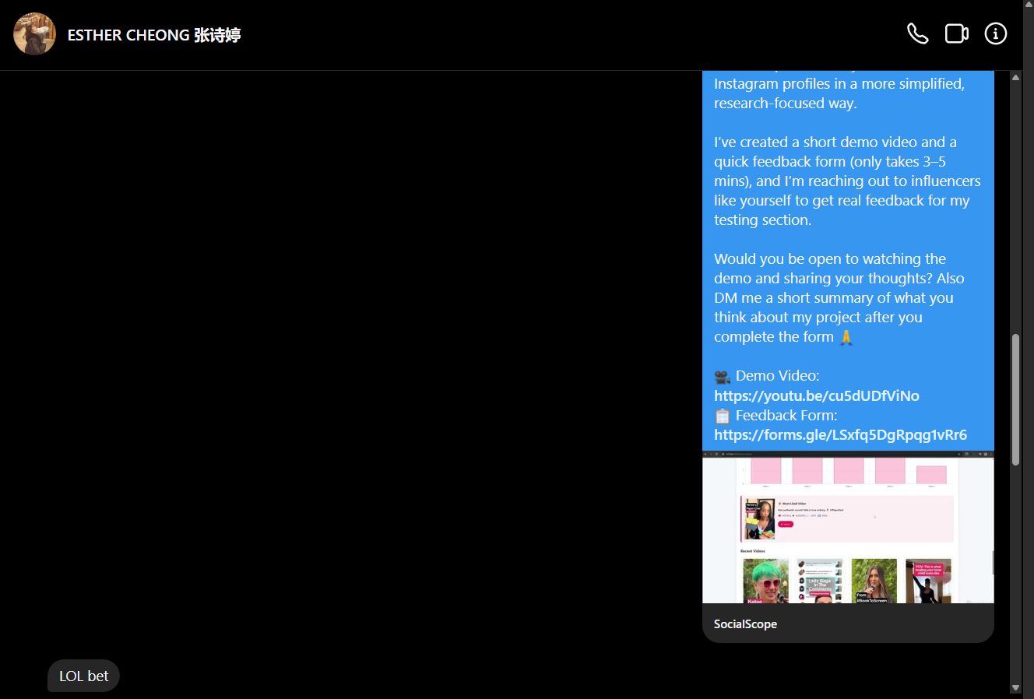
Figure B4.6 – DM and Form entry confirmation
@notf3lix (Instagram/TikTok)
A model and digital creator with a following of over 30,000 on Instagram and 90,000 on TikTok.
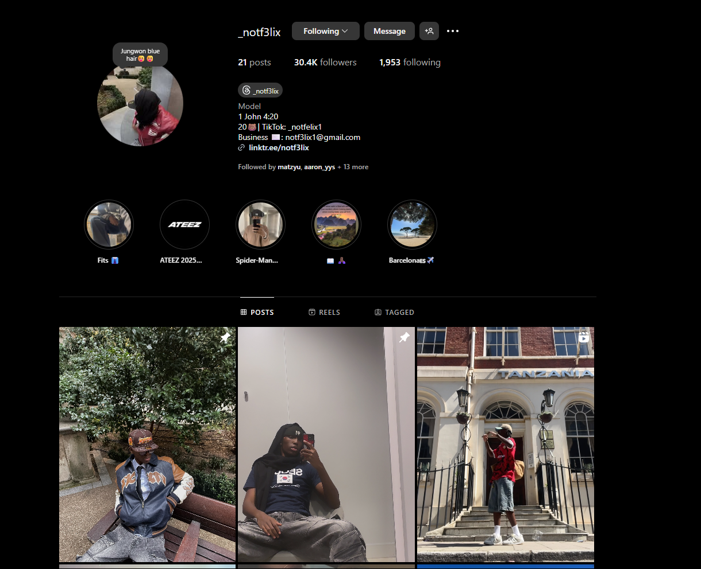
Figure B4.7 - Instagram profile of @notf3lix
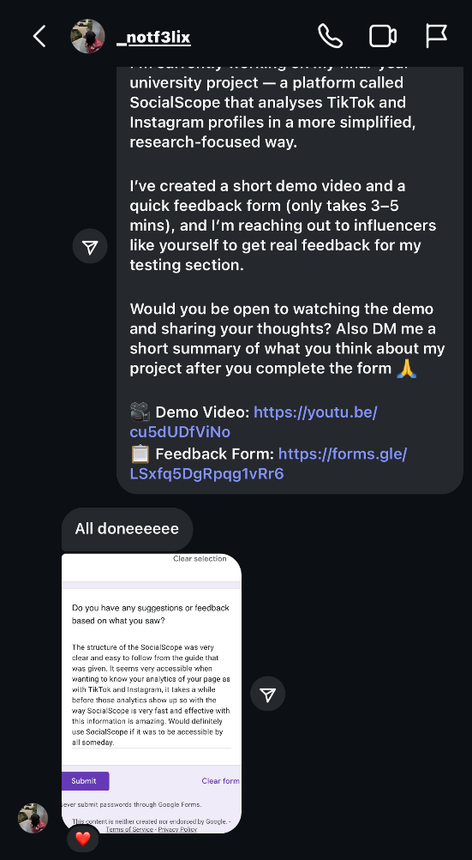
Figure B4.8 - Confirmation of submission

These verified responses offer credibility to the testing process and confirm that SocialScope was evaluated by real content creators with active online presence.

References
Ahmed, W. (2018) Using Social Media Data for Research: An Overview of Tools. Available at: https://doi.org/10.2139/ssrn.3169645 (Accessed: 2 May 2025).
Corso, F., Pierri, F. and De Francisci Morales, G. (2024) ‘What We Can Learn from TikTok Through Its Research API’, Web Science Conference. Available at: https://doi.org/10.1145/3630744.3663611 (Accessed: 2 May 2025).
Firebase (n.d.) Firebase Authentication Documentation. Available at: https://firebase.google.com/docs/auth (Accessed: 2 May 2025).
Flask (n.d.) Flask Web Framework Documentation. Available at: https://flask.palletsprojects.com/ (Accessed: 2 May 2025).
Himawan, A., Priadana, A. and Murdiyanto, A. (2020) ‘Implementation of Web Scraping to Build a Web-Based Instagram Account Data Downloader Application’, International Journal of Informatics Development, 9(2). Available at: https://doi.org/10.14421/IJID.2020.09201 (Accessed: 2 May 2025).
Instagram Premium API – RapidAPI (n.d.) Instagram Analytics API. Available at: https://rapidapi.com/NikitusLLP/api/instagram-premium-api-2023 (Accessed: 2 May 2025).
Perriam, J., Birkbak, A. and Freeman, A. (2019) ‘Digital Methods in a Post-API Environment’, International Journal of Social Research Methodology, 22(3), pp. 275–288. Available at: https://doi.org/10.1080/13645579.2019.1682840 (Accessed: 2 May 2025).
PyTrends (n.d.) Unofficial Google Trends API for Python. GitHub. Available at: https://github.com/GeneralMills/pytrends (Accessed: 2 May 2025).
TikTok Scraper API – RapidAPI (n.d.) TikTok Analytics API. Available at: https://rapidapi.com/tikwm-tikwm-default/api/tiktok-scraper7 (Accessed: 2 May 2025).
WeasyPrint (n.d.) WeasyPrint Documentation. Available at: https://weasyprint.org/ (Accessed: 2 May 2025).
Chart.js (n.d.) Chart.js – Simple yet flexible JavaScript charting. Available at: https://www.chartjs.org/ (Accessed: 2 May 2025).

